

Friday 26th Jan 2024
AWA NEWS
AWA NEWS
4 February 2022

This week has been ‘Football Free’ week in the playground. Year 6 have been demonstrating their creativity by creating and playing various non-football games. Their favourites so far have been ‘Champ’ and skipping!
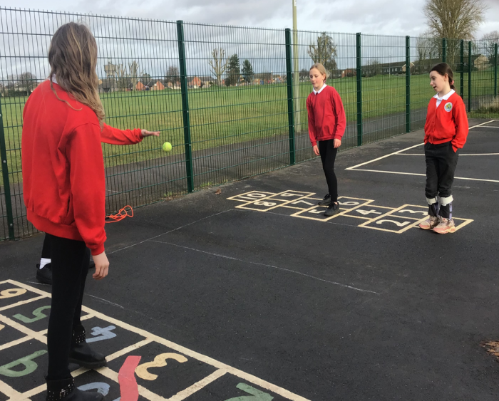
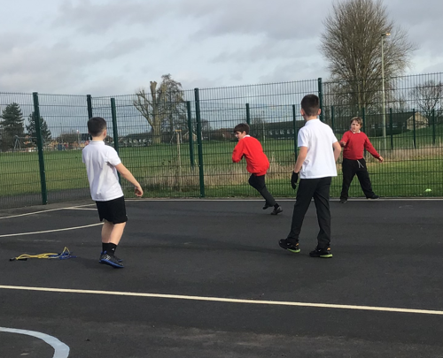
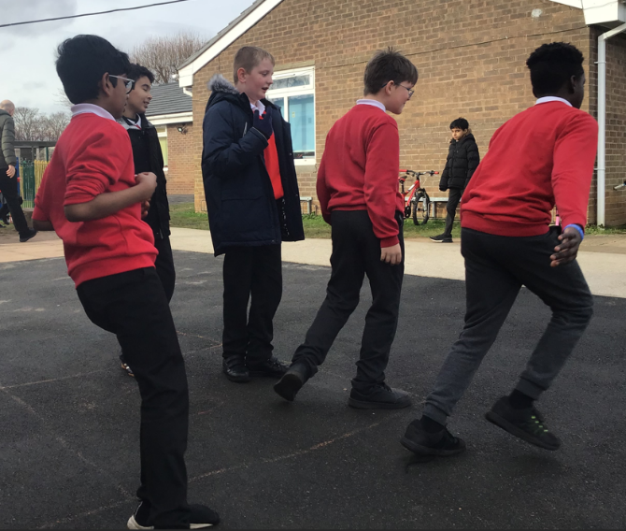
They have enjoyed sharing these games with Year 5 pupils and next week they will share with the rest of the school community by helping the younger children play a greater variety of games in the playground. Well done Year 6!



Community



Y6 at Playtime

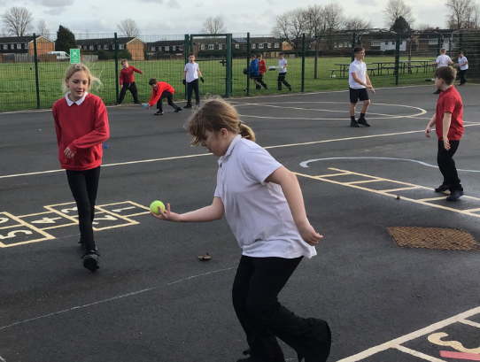
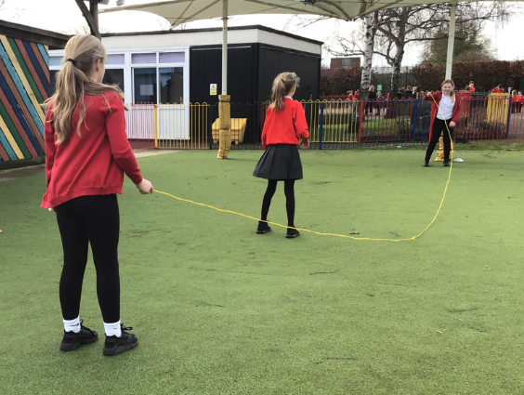

AWA News

#WeCARE Celebration Assembly Awards
Congratulations to the following children for being awarded a CARE value wristband in this week’s celebration assembly:
1 | Respect | Alaya | For perfect behaviour in the afternoon
1 | Aspiration | Taylor | Working so hard in maths and writing lessons
2 | Aspiration | Tami | For amazing independent writing in English this week
2 | Equality | Tommy | For being curious and respectful when learning about different faiths in RE
3 | Respect | Eliot | For showing a huge improvement in behaviours in the classroom and on the playground
3 | Aspiration | Teddy | For showing resilience across all aspects of his learning and developing a positive learning attitude
4 | Aspiration | Harley | For listening to feedback and improving his work
4 | Equality | Nouha | For showing a real awareness of her friends and their needs
5 | Equality | Mohamed | For asking lots of questions in relation to our reading and writing texts about racism
5 | Respect | Harry | For following class rules and encouraging others to do the same
6 | Aspiration | Isla | For an amazing quiet focus at all times in class
6 | Respect | Jayden | Fow making a special effort with his peers, trying to be as positive as possible and making new friends



AWA News

Presentation Prefects – given for amazing handwriting and super neat work!
Year 1 | Taylor
Year 2 | Grayson
Year 3 | Raiden
Year 4 | Cameron
Year 5 | Jacob
Year 6 | Ella


This Week’s Attendance Heroes
Reception | 85%
Year 1 | 85%
Year 2 | 95%
Year 3 | 88%
Year 4 | 94%
Year 5 | 98%
Year 6 | 92%


There is a clear link between attendance and school attainment.
Reduced attendance affects a child’s chances of success at school and beyond.
Please help us in ensuring your child comes to school every day.
Holidays should only be taken during the allocated holiday dates.
Gates open at 08:40 and registration for all year groups is at 08:45 each day. Any child late for school will need to enter school via the main office.

P.E Days for each year group are as follows:
Year 1 | Tuesday | Thursday
Year 2 | Tuesday | Thursday
Year 3 | Tuesday | Friday
Year 4 | Tuesday | Friday
Year 5 | Swimming Wednesday | Thursday
Year 6 | Wednesday | Thursday

Key Dates until half term:
Friday 9th February – Last day of term
Monday 19th February – First day of term

